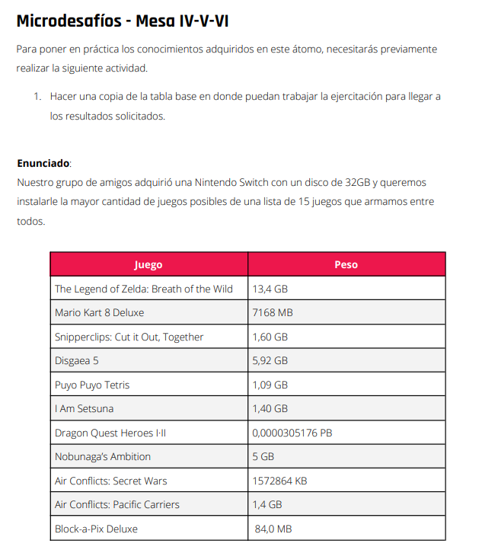

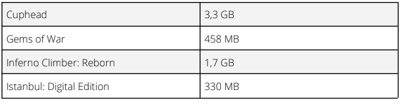

**Respuesta:**

Los juegos para instalar:

-Gems of war

-Air Conflicts: Secret War

-Instabul: Digital Edition

-Snipperclips: Cut ir Out, Together

-Mario Kart 8 Deluxe

-Disgaea 5

-Puyo Puyo Tetris

-I Am Setsuna

-Nobunagas Ambition

-Air Conflicts: Pacific Carriers

-Block-a-Pix-Deluxe

-Cuphead

-Inferno Climber:Reborn